Powershell 3 Lab Review 3

**1. What command would you use to start a job that runs entirely on your local computer?**

Start-Job

**2. What command would you use to start a job that was coordinated by your computer, but whose contents were processed by remote computers?**

Invoke-Command -ComputerName ... -ScriptBlock {Start-Job -ScriptBlock {...}}

**3. Is ${computer name} a legal variable name?**

No, because it contains a space.

**4. How could you display a list of all variables currently defined in the shell?**

Get-Variable

**5. What command could be used to prompt a user for input?**

Read-Host

**6. What command should be used to produce output that normally displays on the screen, but that could be redirected to various other formats?**

Write-Output

**Task 1**

**Create a list of running processes. The list should include only process name, ID, VM, and PM columns. Put the list into an HTML-formatted file named C:\Procs.html. Make sure that the HTML file has an embedded title of “Current Processes”. Display the file in a web browser and make sure that title appears in the browser window’s titlebar.**

PS> Get-Process | Select-Object ProcessName, Id, VirtualMemorySize64, PagedMemorySize64 | ConvertTo-HTML -Title "Current Processes" | Out-File "C:\Procs.html"

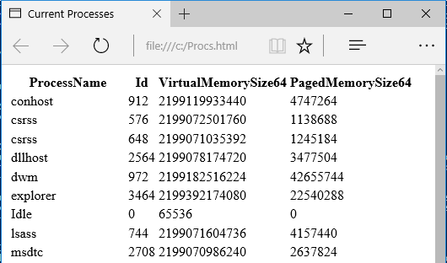

**Task 2**

**Create a tab-delimited file named C:\Services.tdf that contains all services on your computer. "`t" (backtick t inside double quotes) is PowerShell’s escape sequence for a horizontal tab. Include only the services’ names, display names, and statuses.**

PS> Get-Service | Export-CSV "C:\Services.tdf" -Delimiter "`t"

PS> Get-Content "C:\Services.tdf"

#TYPE System.ServiceProcess.ServiceController

"Name" "RequiredServices" "CanPauseAndContinue" "CanShutdown" "CanStop" "DisplayName" "DependentServices" "MachineName" "ServiceName" "ServicesDependedOn" "ServiceHandle" "Status" "ServiceType" "StartType" "Site" "Container"

"AJRouter" "System.ServiceProcess.ServiceController[]" "False" "False" "False" "AllJoyn Router Service" "System.ServiceProcess.ServiceController[]" "." "AJRouter" "System.ServiceProcess.ServiceController[]" "SafeServiceHandle" "Stopped" "Win32ShareProcess" "Manual"

"ALG" "System.ServiceProcess.ServiceController[]" "False" "False" "False" "Application Layer Gateway Service" "System.ServiceProcess.ServiceController[]" "." "ALG" "System.ServiceProcess.ServiceController[]" "SafeServiceHandle" "Stopped" "Win32OwnProcess" "Manual"

...

**Task 3**

**Repeat task 1, modifying your command so that the VM and PM columns of the HTML file display values in megabytes (MB), instead of bytes. The formula to calculate megabytes, displaying the value as a whole number, goes something like $_.VM / 1MB -as [int] for the VM property.**

PS> Get-Process | Select-Object ProcessName, Id, @{l="VM (MB)"; e={$_.VirtualMemorySize64 / 1MB –as [int]}}, @{l="PM (MB)"; e={$_.PagedMemorySize64 / 1MB -as [int]}} | ConvertTo-HTML -Title "Current Processes" | Out-File "C:\Procs.html"

